bora shiva

[Company name]  [Company address]

DOCKER

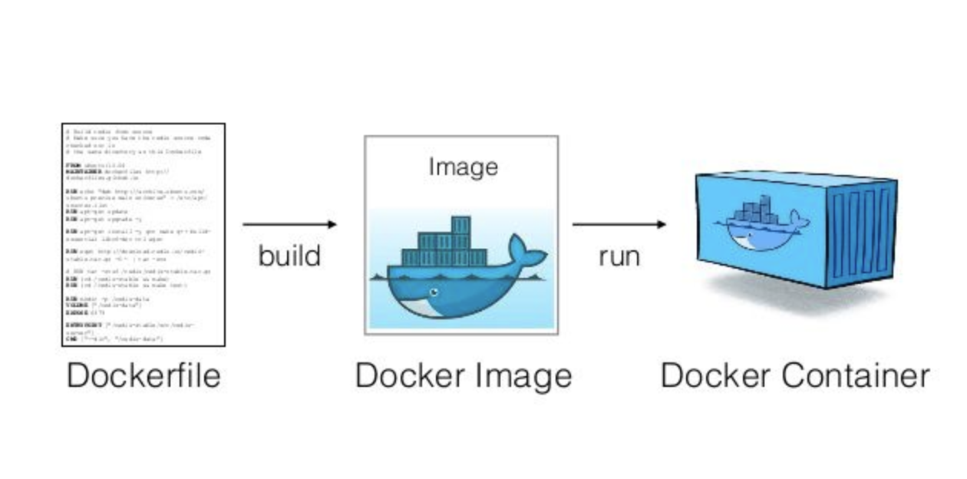

* **Docker** is a tool designed to make it easier to create, deploy, and run applications by using containers. **Containers** allow a developer to package up an application with all of the parts it needs, such as libraries and other dependencies, and ship it all out as one package
* **Docker** is a container management.
* **Container** having binary and library files, it will use the kernel of host OS
* **Container** having required files remaining files we get from kernel OS
* **Containers** easy to scale(easy start, easy stop, east delete)
* **Containers** is self sustained(all necessary dependencies downloaded automatically)
* **Virtualization** means run multiple OS on single physical system.
* **Hypervisor** is a program that would enable you to host several different machine on a single machine hardware.
* Hypervisor is a software component
* It works on host machine
* Enable virtualization
* Distributes host hardware resources
* Provides is isolation
* Guest cannot affect host or other guest
* **Docker** **Image** is a source of container
* **Image** is a layer by layer architecture.
* **Dockerfile** is used to create images.
* **Dockerfile :**

FROM java:latest

MAINTAINER shiva shivardy06@gmail.com

LABEL env=production

ENV apparea /var/jenkins_home

Run mkdir -p $apparea

ADD ./jenkins.war $apparea

WORKDIR $apparea

CMD ["java","-jar","jenkins.war"]

* **To run a docker file**: docker build –t Jenkins . (dot declared current path of docker file) (Jenkins is a image name)
* **Create a container through image:**

Docker run –p 8080:8080 jenkins /bin/bash

* Note: if u want to remove image first stop the container done by image.
* **Remove image & remove all images:**

Docker rmi image

Docker rmi $(docker images –a –q)

* Details of container

Docker inspect container_id

* **Stop container & stop containers:**

Docker stop container_id

Docker stop $(docker ps –a –q)

* **Remove container & remove containers:**

Docker rm container_id

Docker rm $(docker ps –a –q)

* **Open a container:**

Docker exec –ti container_id /bin/bash

* **Docker volume:** In order to be able to save (persist) data and also to share data between containers, Docker came up with the concept of volumes. Quite simply, volumes are directories (or files) that are outside of the default Union File System and exist as normal directories and files on the host filesystem.
* **Create docker volume:** docker volume create myvol1
* **List of docker volumes:** docker volume ls
* **Details of docker:** docker volume inspect myvol1
* **Remove docker volume:** docker volume rm myvol1
* **Remove unused volumes:** docker volume prune
* Docker run --name test -v myvol1:/home/one/Jenkins_home -p 8081:8080 -p 50000:50000 image
* Dockerhub login
* Docker tag image ID shivardy06/imane_name:latest
* Docker push shivardy06/image_name:latest